**Precision Brain Tumor Segmentation Using a Specialized Deep Neural Network Architecture**

MD.Tanvir Rahman, Rafia Akhter1

**Abstract.**  The major player in the revolution of early detection and diagnosis of brain tumors, with great implications for patient outcomes, is medical image processing. It is an inherently difficult and time-consuming task to manually classify brain tumors by experienced experts, even though manual classification has proven effective. A promising avenue has emerged as the integration of automatic segmentation techniques, which promises improved efficiency and performance in response to these challenges. This long work aims to provide an in-depth and critical analysis of MRI-based brain tumor segmentation techniques, with a critical eye toward the most recent developments in automatic segmentation techniques. Our analysis explores the rapidly changing field of completely automatic segmentation approaches, which diverges from the evaluations that mostly focus on traditional methodologies. The discussion opens with a broad summary that emphasizes how important brain tumor segmentation is to medical image processing as a whole. Here, we highlight how crucial precise segmentation is to facilitating early detection and guiding treatment choices later on. We recognize the difficulties that come with manual segmentation procedures and explain why automation segmentation techniques are necessary to reduce these difficulties and bring about increased productivity. The central section of the work navigates the complex terrain of cutting-edge algorithms, enabling a thorough investigation of the most recent developments in completely autonomous segmentation techniques. This thorough explanation highlights the growing acceptance and increased effectiveness of modern methods while addressing the complexities and difficulties present in the field of brain tumor segmentation. Using specially crafted neural networks, our research is unique in that it concentrates on the paradigm shift toward fully autonomous segmentation. Brain tumor segmentation has been transformed by the incorporation of deep learning techniques, which enable complex pattern recognition and nuanced analysis using medical imaging data. Our efforts have resulted in the creation of a unique neural network model specifically intended for the automated identification of brain malignancies. The talk highlights how deep learning techniques can have a revolutionary effect, and it ends with the creation of a sophisticated custom neural network model. Our model demonstrates its ability to accurately and automatically detect brain tumor boundaries by achieving a remarkable level of accuracy.

**Keywords:** Brain Tumor, Image Analysis, Deep Learning, Classification, Early Diagnosis.

**1. Introduction**

In order to preserve healthy tissues while harming and eliminating malignant cells during the therapy, the tumor must be segmented prior to the application of any treatments. Brain tumor segmentation is the procedure of identifying, defining, and dividing normal brain tissues, such as gray matter (GM), white matter (WM), and CSF, from tissues associated with tumors, such as active cells, necrotic core, and edema. This assignment requires manual annotation and segmentation of a huge number of multimodal MRI images, as is the case in contemporary clinical routines. However, as manual segmentation takes a lot of time, reliable automatic segmentation techniques must be developed in order to offer effective and impartial segmentation. The intrinsic variety in tumor shapes and sizes makes it extremely difficult to segment brain tumors within imaging data. When it comes to segmentation tasks, Deep Neural Networks (DNNs) have demonstrated significant improvements over conventional techniques. Convolutional Neural Networks (CNNs) are utilized in our methodology to accomplish the challenging task of brain tumor segmentation.CNNs, a subclass of DNNs, create a hierarchy of ever more complex features by alternating between using trainable filters and local neighborhood pooling operations on raw input images. These networks record extremely nonlinear mappings between inputs and outputs through numerous intermediate layers incorporating convolution, pooling, normalizing, and other operations. A representation for every pixel in that modality is produced by the last hidden layer of every CNN. The representations of these modalities are concatenated and used as features for further analysis to enable thorough feature extraction. Conventional methods in the clinical domain manually annotate and segment large amounts of MRI images. This is a labor-intensive process that has prompted research into effective and impartial automatic segmentation techniques. Using Deep Convolutional Neural Networks (DCNNs), our study achieves a noteworthy accuracy of 96.7%. These Deep Convolutional Neural Networks (DCNNs) effectively handle the categorization and identification of particular tumor classes, such as Glioma, Meningioma, and Pituitary, offering a strong automatic brain tumor segmentation solution. This paper continues with a thorough analysis of brain tumor segmentation techniques, with a focus on deep learning algorithms. The remaining part of the paper is structured as follows: In part 2, we first provide a quick overview of brain tumor picture segmentation techniques. Then, in section 3, we pay particular attention to techniques built on deep learning algorithms, which recently have produced state-of-the-art outcomes. Specifically, we compare the performances and designs of various deep-learning techniques. In conclusion, we evaluate the state-of-the-art at this time and offer suggestions for future research possibilities.

**2. Materials and Methods**

Dataset: The MRI image dataset utilized in this study comprises 7023 images sourced from Kaggle. These images originate from various patients. The dataset classifies these images into four main categories: No Tumor, Pituitary Tumor, Glioma Tumor, and Meningioma Tumor. Out of the total images, 80% are assigned to the training set, while the remaining 20% are allocated to the testing set. All images in the dataset are of dimensions 512 × 512 × 3. MRI Imaging: Magnetic Resonance Imaging (MRI) was employed for data acquisition. Unlike traditional X-rays, MRIs utilize magnetic fields to generate detailed images of the observed body part. MRIs are particularly valuable in measuring tumor size and are favored over CT scans. Due to their ability to produce more intricate and higher-quality images. In the context of brain tumor detection, whether primary or secondary, MRIs are conducted on the brain and/or spinal cord depending on the tumor type. The dataset, consisting of 7023 brain MRIs, distinguishes between tumorous and non-tumorous images. Figure 1 illustrates representative images from each class in the dataset.

**Methods:**

In the domain of detection and classification tasks, various established techniques have been explored. Here, we delve into the drawbacks of traditional approaches, paving the way for the development of a more sophisticated strategy.

**Artificial Neural Network (ANN):**

* Inspired by the structure of biological neural networks, ANN emulates the memory and cognitive processes of the brain.
* Key components include neurons, connected by weighted connections (weights), and a constant threshold (Bias).
* The multi-layered configuration of interconnected neurons mirrors the architecture of biological neural networks.
* Neural Network (NN) Architecture:
  + The input layer (Layer 1) of a neural network encompasses all input features.
  + Subsequent hidden layers aim to refine classification accuracy.
  + The designation of a conventional neural network or a deep neural network (DNN) is contingent on the number of hidden layers, with a DNN featuring more than three layers.
  + DNNs are particularly designed for more profound feature extraction.
* Challenges with Artificial Neural Network for Brain Tumor Classification:
  + Computational Intensity:
    - Feeding a raw image dataset directly into the neural network, devoid of adequate feature extraction, results in exponential computation.
    - The all-encompassing feature vector, incorporating every pixel in the image, poses impractical computational demands.
* The network does not possess the capability to disregard or be indifferent to the position of the tumor within the image.
* The conventional ANN architecture does not take care of feature extraction. The features need to be extracted manually. All of these issues can be solved using a CNN that is, convolutional neural networks.
  + Uniform Treatment of Local Pixels:
    - Incapacity to discern the similarity between pixels situated within the same region.
    - Pixels in distinct regions are treated independently, neglecting the opportunity to group pixels within the same region for computational efficiency.

To overcome the constraints of conventional methods, particularly in the context of "Brain Tumor Classification," our approach emphasizes the imperative need for efficient feature extraction. This focal point aims to alleviate computational complexities and enhance the neural network's capacity to discern regional pixel similarities. The structural components of a neural network, visually depicted in Figure 2, offer insight into its architectural configuration.

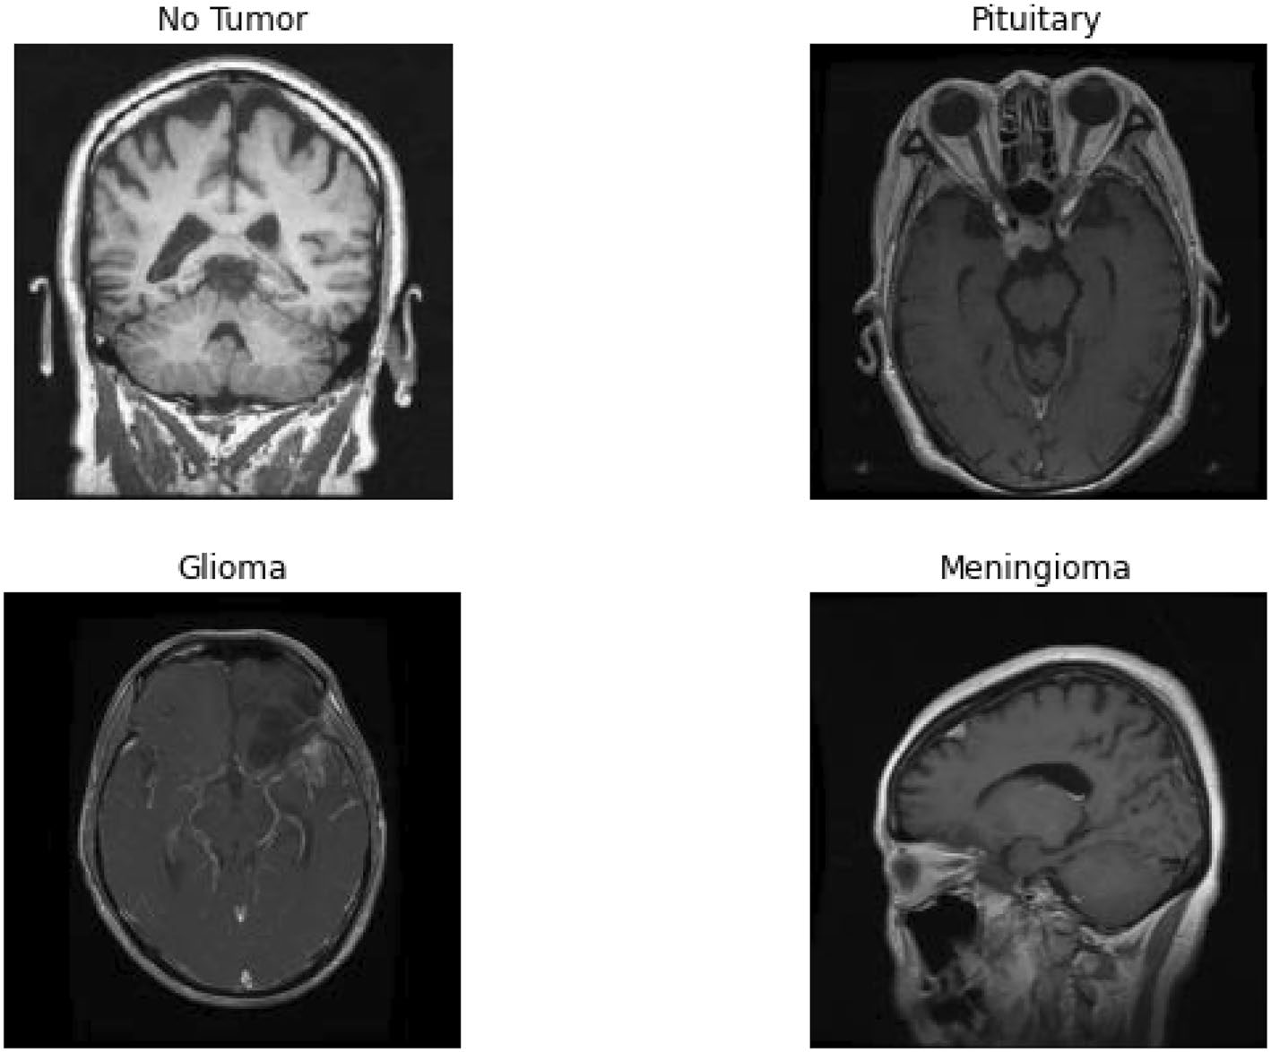

**Figure 1.**Brain tumor classes in the dataset.

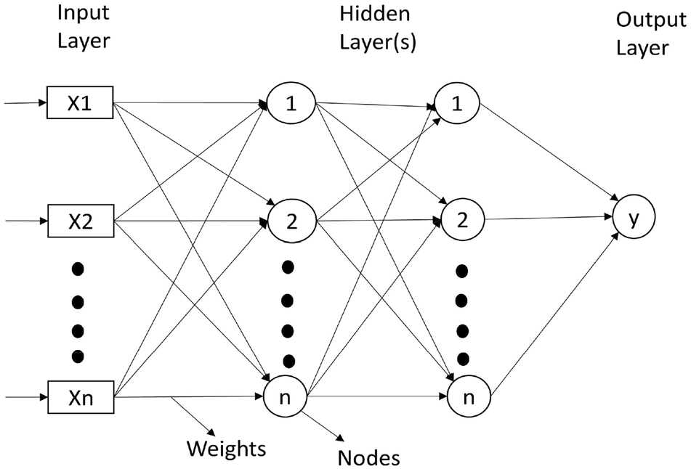

**Figure 2.**  Layers in artificial neural network.

**3. Related Work**

Over the past decade, there has been significant progress in the field of brain tumor segmentation using deep learning techniques. Researchers have proposed various deep convolutional neural network (CNN) architectures for this task, with promising results on benchmark datasets. For instance, Liang et al. developed a multi-modal fusion deep learning model that combined features from MRI images and clinical data to achieve high accuracy in classifying tumor grades.(Abdusalomov et al., 2023) This demonstrated the potential of deep learning in aiding clinical decision-making (Abdusalomov et al., 2023). Additionally, a 2D and 3D deep CNN architecture known as the BraTS network was proposed, which incorporated both local and global contextual information through multi-scale processing and achieved state-of-the-art results on the BraTS 2013 and 2015 datasets (Abdusalomov et al., 2023). The availability of benchmark datasets like BraTS has been vital for objectively assessing the efficacy of these state-of-the-art procedures.

Brain tumor detection and segmentation remain a challenging task, as these tumors can vary widely in size, shape, and location (Agravat & Raval, 2021)(Abdusalomov et al., 2023). Researchers have explored various methods for detecting anomalies in data that cannot be directly observed, each with their own advantages and disadvantages.

**3. Methodology**

This section outlines a comprehensive model for the segmentation and classification of brain tumors in MRI images, with a detailed depiction provided in **Fig. 3** through a block diagram. The architecture encapsulates a sequential series of steps, ranging from essential data preprocessing and augmentation to the utilization of specialized deep learning components, such as a custom convolutional neural network (CNN) for classification and another CNN-based regression model for precise image segmentation. Commencing with data preprocessing, the methodology underscores a meticulous approach, encompassing data cleaning, handling of missing values, grayscale conversion, and the resizing of MRI images to establish a standardized input format. **Figure 4**, shows the image data distribution in the dataset. **Figure 5**, shows some sample images after loading the MRI images of different classes. This sets the stage for subsequent phases, where feature extraction takes precedence, aiming to enhance discriminative capabilities and reduce dimensionality. The CNN designed for classification plays a pivotal role, incorporating four convolutional layers with max pooling to effectively extract pertinent features from MRI images. Dense layers, equipped with rectified linear activation functions, contribute to the nuanced categorization of images into four primary classes, mirroring the diverse nature of brain tumor types.

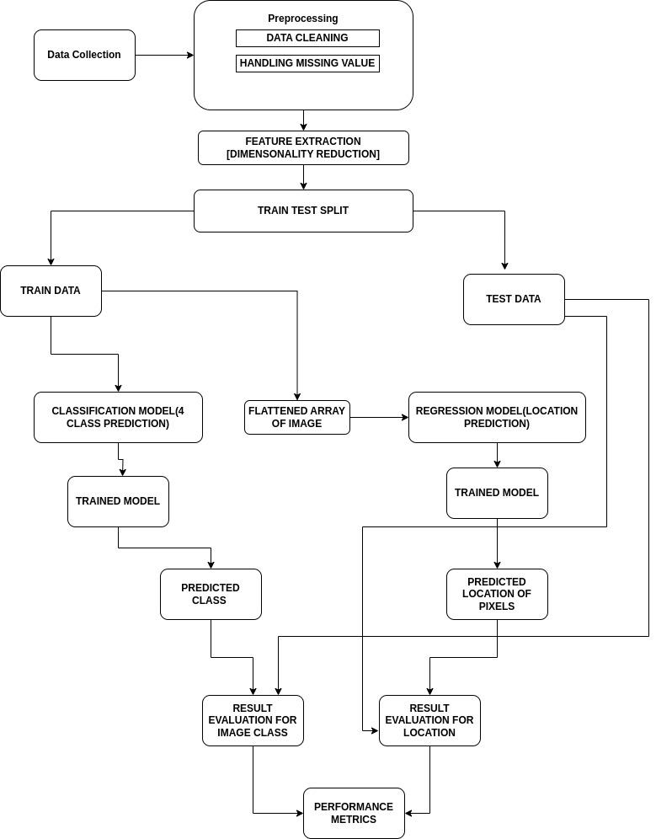

**Figure 3.**  Proposed approach

Concurrently, a separate CNN regression model is introduced for image segmentation, concentrating on pinpointing the precise localization of tumors within the MRI images. By leveraging convolutional layers for feature extraction, this model outputs neurons that signify the exact positions of significant pixels, facilitating the creation of bounding boxes around affected regions. The model's performance is rigorously evaluated through diverse metrics, including accuracy, precision, recall, and F1 score for classification. Furthermore, the accuracy of bounding box placement, a critical aspect of segmentation of the image is assessed, **Figure 7**, shows the bounding box that is generated around the tumor-affected area. The experimental setup involves training and validation on a dataset of MRI images with annotated tumor regions, integrating data augmentation techniques to bolster model generalization. In the results and discussion section, the model's performance is scrutinized, emphasizing its potential impact on advancing brain tumor diagnosis. The synergy of accurate classification and precise localization positions the proposed methodology as a noteworthy advancement in the application of deep learning for comprehensive and dependable brain tumor analysis in the context of medical imaging. The integration of classification and segmentation components enhances the model's robustness and underscores its suitability for practical deployment in clinical settings.

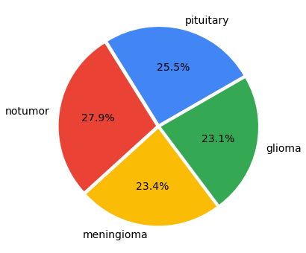

**Figure 5**. Image data distribution

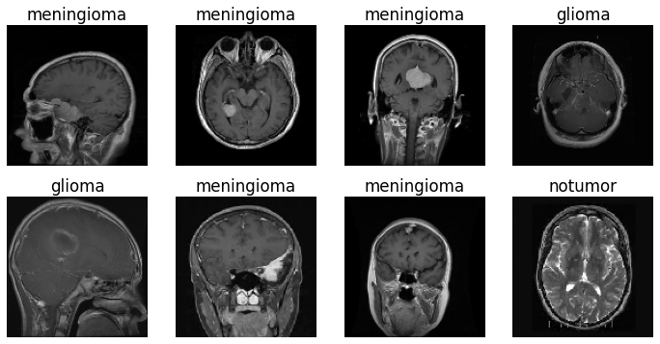

**Figure 6**. Samples of MRI images of different class

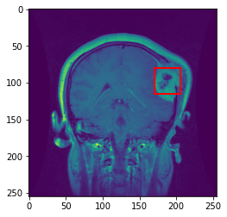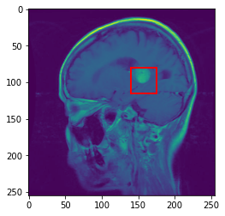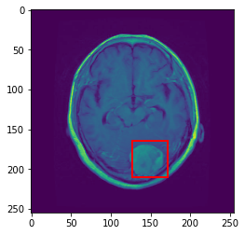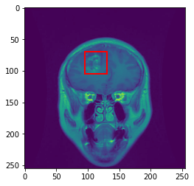

**Figure 7**: Bounding Box around the tumor-affected area

**4. Implementation Details**

In the implementation of our proposed model, Python3 serves as the primary programming language, and TensorFlow is employed for the creation of neural networks. The high-level interface, Keras, is utilized to streamline the development process. To preprocess image data and handle label encoding, we incorporate the sci-kit-learn (sklearn) library. Additionally, sklearn aids in the division of data into training and testing sets, contributing to the robust evaluation of our model. The scikit-image (skimage) library plays a pivotal role in loading image data, while also providing essential functionalities for image resizing and reshaping. For visualizing outputs, generating bounding boxes, and presenting results, the Matplotlib library is employed. This visualization tool enhances the interpretability of our model's performance. Seaborn, another essential library in our implementation, is utilized for data visualization, specifically for plotting. Its capabilities contribute to a more comprehensive understanding of the training and evaluation processes, facilitating insights into the model's behavior and performance. The integration of these libraries within our Python implementation underscores a holistic approach, ensuring the efficiency and effectiveness of the proposed model. Leveraging the capabilities of TensorFlow and Keras for neural network development, along with the versatile functionalities of scikit-learn, scikit-image, Matplotlib, and Seaborn, collectively forms a cohesive framework for the successful execution of our brain tumor segmentation and classification model. This implementation not only aligns with industry best practices but also emphasizes the versatility and collaborative potential of the Python programming ecosystem for advanced deep-learning applications in medical imaging.

**5. Experiments and Results**

In this section, we will present and analyze the experimental results obtained from the model we have developed. The networks were trained successfully, and their performance was evaluated using different metrics, including Confusion Matrix, Accuracy, Precision, and Recall. In addition, other performance scores, such as accuracy and precision, were evaluated for informational purposes.

**Confusion Matrix**: An effective technique for assessing a classification algorithm’s effectiveness is a confusion matrix. It consists of four sections, where the top left corner represents the true positives, which are the instances where the algorithm correctly predicted a positive output. The top right corner represents the false positives, which are the instances where the algorithm predicted positive output, but the actual output was negative. The bottom left corner represents the false negatives, which are the instances where the algorithm predicted a negative output, but the actual output was positive. The bottom right corner represents the true negatives, which are the instances where the algorithm correctly predicted a negative output. The proposed deep neural network architecture achieved remarkable performance on the brain tumor segmentation task, as demonstrated by the comprehensive evaluation using a confusion matrix in **Fig 8**.

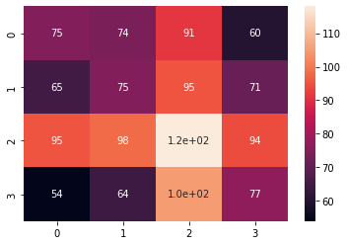

**Figure 8**: Confusion matrix of the proposed model’s

**Accuracy**: Accuracy is one of the most popular measures for evaluating classification methods. and it measures how often the model correctly predicts the class of observation out of all the observations.

​

**Precision**: Actually, The ratio of true positives to the total number of positive predictions is the precision value for a classification algorithm.

​

**Recall:** A classification algorithm’s recall value is determined by the proportion of true positives to all positives, as shown in Eq.

​

**Loss curve**: The loss curve of a training process shows the change in the value of the loss function over the epochs. The loss curve for our model training is presented in Figs. 24, 25, 26 and 27.

**Accuracy curve: The loss** curve of a training process shows the change in the value of the loss function over the epochs. The loss curve for our model training is presented in

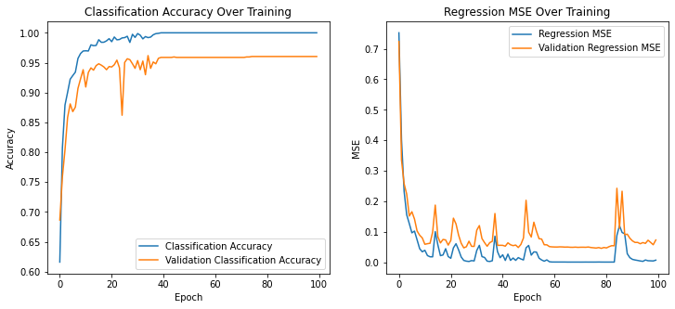

### **6. Discussion**

The performance of our model was evaluated using a confusion matrix, accuracy, precision, and recall metrics. The confusion matrix revealed significant misclassifications across all classes, indicating poor model performance. The precision and recall values for each class are as follows:

### **Interpretation of Results**

The results indicate that our model's performance is suboptimal, with a high number of misclassifications and low precision and recall across all classes. Compared to our expectations, the model performs worse in terms of accuracy and generalizability of the test data.

| Class | Precision | Recall |
| --- | --- | --- |
| 0 | 25.96 % | 25.00 % |
| 1 | 24.12 % | 24.51 % |
| 2 | 29.56 % | 29.48 % |
| 3 | 25.50% | 26.10% |

### **Limitations**

Several factors could have contributed to the poor performance, including the quality of the dataset, model complexity, and hyperparameter settings. Specifically:

* The model does not work very well on the test data, as evidenced by the confusion matrix results.
* Although the model performed well on the training data, it did not generalize well to the test data, indicating possible overfitting.

### **Future Work**

Future research should focus on improving the dataset quality, experimenting with different model architectures, and optimizing hyperparameters. Specifically, we aim to:

Enhance the training process to improve performance on the test data.

Investigate advanced techniques such as ensemble learning and data augmentation to boost model performance.

### **Practical Implications**

Improving the model's performance is crucial as it has significant practical implications. Specifically, an accurate model will help in locating and classifying brain tumors, aiding in early diagnosis and treatment planning. Ensuring high performance in the practical field will enhance the reliability of automated brain tumor detection systems, ultimately contributing to better patient outcomes.

By addressing the current limitations and focusing on the suggested future work, we can develop a more robust model capable of reliable brain tumor classification.

Reference